AGM and What’s On Twitter?
Friday 5th October 2018
Location: IWM

12.30 Registration
Refreshments available from the Cafe

13.00 Chairs Address, Aisha Burtenshaw, UKRG Chair

13.05 AGM
- Minutes of last AGM, Aisha Burtenshaw
- Chair’s Annual Review, Aisha Burtenshaw
- Committee Reports
Treasurer, Aisha Burtenshaw
Events, Emma Denness and Jacqui Austin
Membership, Fran Coles
Web Officer and Web Editor, Nicola Farrington
Corporate and Development Officer, Jenny Fewery
Professional Development Officer, Lyn Wall
Supporting Officer, Fran Coles
- Membership changes, Fran Coles
- Constitution changes, Fran Coles
- AOB

14.30 Break
Tea/Coffee and biscuits will be served in the foyer

15.00 Address from IWM

15.10 Keynote Speaker – Using social media to engage new audiences. Paul Barnard, Director of Communications and Development (Assistant Chief Executive) Chatham Historic Dockyard Trust

15.30 William Brown, Arts Council England
Security and social media/ Couriers and Social Media

15.50 Q&A Group discussions
Do you have guidelines? How do you use them? Would UKRG guidelines be useful? What is/ isn’t acceptable to post? Are your couriers posting on social media? How does your institution promote projects on social media?

16.30 ERC update, Alyson Rolington

16.40 CEN update, Jen Kaines

16.50 Chairs Close, Aisha

17.00 – 18.00 Drinks reception - Park View Room, IWM Join us for a glass or two and nibbles!

18.00 - late
A space is booked at The Walcot 1830,171 Kennington Road, SE11 6SF

With special thanks to our host, Imperial War Museum

Getting to IWM
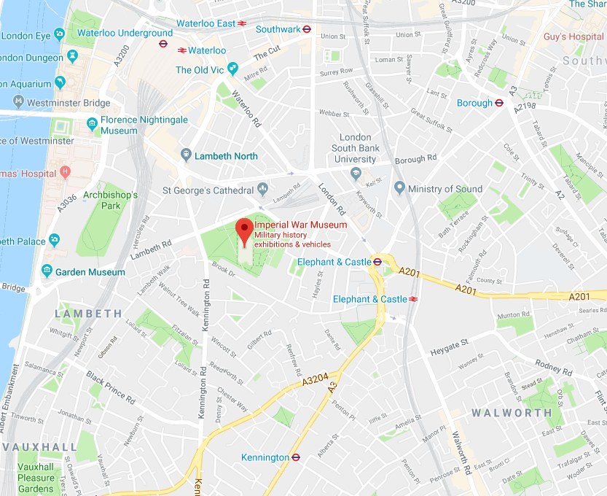
BY TUBE Brough, Elephant and Castle, Waterloo, Kennington

