Wellcome to the Jungle: Loans of Fun

09 February 2018
Henry Wellcome Auditorium, Wellcome Collection, 183 Euston Rd, Bloomsbury, London NW1 2BE

12.30 Registration Tea and coffee will be served in the Williams Lounge

13.00 – 13.10 Welcome and Chair’s Address, Aisha Burtenshaw, UKRG Chair

13:10 – 13:20 Simon Chaplin, Director, Wellcome Collection
A quick hello

13.20 – 13:50 ‘A museum of modern nature’. Emma Smith, Exhibitions Registrar, Wellcome Collection
Talking about the Wellcome Collections recent exhibition ‘A museum of modern nature’. The exhibition was crowd-sourced and made up entirely of objects lent and donated by the public, telling stories about their personal relationship with nature in the 21st century. The objects varied from an elderflower, to a sun catcher, a collection of model cars and even a slice of bread! It was a big experiment with visitors, which was both challenging and rewarding.

13.50 – 14:20 How do you solve a problem like a Fatberg? Helen Parkin, Assistant Registrar, Museum of London
The Museum of London announced in September 2017 that it was aiming to ‘collect’ a portion of the Whitechapel Fatberg, the enormous mass of fat, wet wipes and other less-than-pleasant stuff found in the Victorian sewers under East London. Helen Parkin looks at why and how the museum will be displaying the specimen, and how you go about applying your collections management procedures to an object like a fatberg.

14.20 – 14.50 Buzz, bubble, and stir: a recipe for trouble. Brandi Pomfret, Echelon Arts Management
Serving the needs of Contemporary Art frequently leads Registrars and Exhibition Managers into a landscape of unpredictable demands. Few of the traditional rules apply when one is asked to acquire and exhibit art featuring live animals, running water, food production, and the interaction of museum-goers. This session illustrates past challenges encountered and aims to provide insight into the installation of artworks that are inherently self-destructive, and potentially dangerous to other artworks and visitors alike.

14.50 – 15.30 Comfort Break Tea, coffee and biscuits will be served in the Williams Lounge

15.30 – 16.00 ‘When is a gun a gun?’. Hannah Kauffman, Deputy Registrar, V&A
On 6 May 2013, Texan law student Cody Wilson fired the world’s first 3D-printed firearm, The Liberator. The invention of this so-called ‘wiki weapon’ triggered intense moral and political debate, not only about gun ownership, but also around new manufacturing technologies and the unregulated sharing of designs online. As part of the Museum’s ‘rapid response’ collecting policy, the V&A immediately began exploring how to obtain a version of the gun. During the complex process of importing the gun from the US, the legal hurdles became as important to the story as the object itself.

16.00 – 16.30 Landseer in a Lorry. Janice Slater, Head of Collections Management, National Galleries of Scotland
Hear how an idea sparked by a comedy sketch show was turned into reality when National Galleries of Scotland exhibited their new acquisition Sir Edwin Landseer’s The Monarch of the Glen in the back of a truck outside a school in rural Perthshire. Colleagues worked together to find solutions to concerns regarding environmental conditions, security and access to offer a unique up close and personal experience with this work.

16.30 – 16.40 Alyson Rolington, European Registrars Conference Chair
2018 London European Registrars Conference update

16.40 - 16.50 Nadine Loach, Chair of the Sustainable Exhibitions for Museums Network
sharing the ‘Greening Exhibitions Survey’, launching at the beginning of 2018 and addressing the (environmental) sustainability which can be a challenge for registrars.

16.50 – 17.00 Summary and Close, Aisha Burtenshaw, UKRG Chair

With many thanks to our host, Wellcome Collection

Please join us after the event for networking drinks at The Crown & Anchor – Euston where we have a space reserved from 17:00: https://www.thecrownandanchornw1.co.uk/

Getting to Wellcome Collection

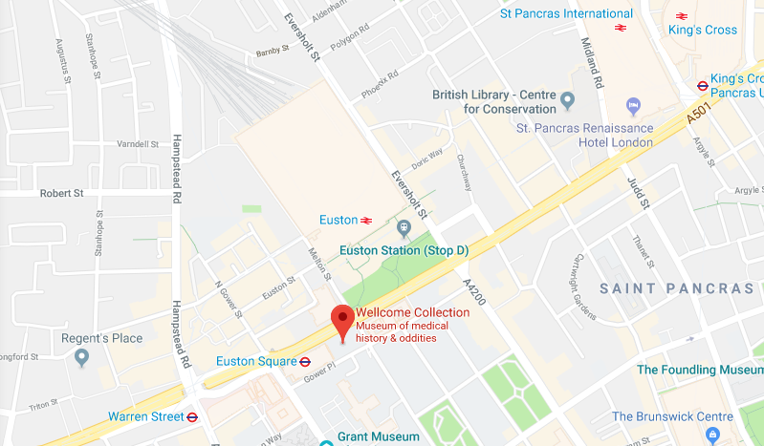

BY TUBE Euston Station: Northern Line/ Victoria Line, 3 min walk
Euston Square: Circle Line, Metropolitan and Hammersmith and City Lines, 1 min walk

BY TRAIN Kings Cross/ St Pancras: 20 min walk

Euston Station: 3 min walk

